

**Report**

**on**

**Emerging Technologies**

**GE103**

by

**Name: Khushi Aggarwal**

**Roll No: 2110990773**

**Batch 2021**

**Session 2021-22**





Index

|  |  |  |
| --- | --- | --- |
| **S. No.** | **Name of the Emerging Technology** | **Page No.** |
| 1. | **Artificial Intelligence & Machine Learning** | 1-5 |
| 2. | **Big Data & Fintech** | 6-9 |
| 3. | **AI (Autonomous Vehicles)** | 10-13 |
| 4. | **Creative Innovative India** | 13-16 |
|  |  |  |
|  |  |  |
|  |  |  |
|  |  |  |
|  |  |  |
|  |  |  |
|  |  |  |

Artificial Intelligence

Introduction

AI is embedded in everyday life, business, government, medicine and more. The purpose of AI is to augment human intelligence. IBM believe AI should make all of us better at our jobs, and that the benefit of the AI era should touch the many, not just the elite one.

There are so many amazing ways artificial intelligence and machine learning are used behind the scenes to impact our everyday lives. AI assists in every area of our lives, whether we’re trying to read our emails, get driving directions, get music or movie recommendations. Following are some examples of how AI is used in day-to-day activities:

Social media, Digital assistance, Self-Driving and Parking vehicles, Email communication, Web searching, Stores and services, Offline experiences, and many more.



Detail

Weak AI—also called Narrow AI or Artificial Narrow Intelligence (ANI)—is AI trained and focused to perform specific tasks. Weak AI drives most of the AI that surrounds us today. ‘Narrow’ might be a more accurate descriptor for this type of AI as it is anything but weak; it enables some very robust applications, such as Apple's Siri, Amazon's Alexa, IBM Watson, and autonomous vehicles. Strong AI is made up of Artificial General Intelligence (AGI) and Artificial Super Intelligence (ASI). Artificial general intelligence (AGI), or general AI, is a theoretical form of AI where a machine would have an intelligence equalled to humans; it would have a self-aware consciousness that has the ability to solve problems, learn, and plan for the future. Artificial Super Intelligence (ASI)— also known as superintelligence—would surpass the intelligence and ability of the human brain. While strong AI is still entirely theoretical with no practical examples in use today, that doesn't mean AI researchers aren't also exploring its development.

**IBM AI & AUTOMATION PRODUCTS**

|  |  |
| --- | --- |
| **Pre-built Watson Applications**  **Watson Discovery**  **Watson Assistant**  **Watson Natural Language Understanding**  **Watson Knowledge Studio**  **Watson API Kit** | **Watson API’s**  **Watson Visual Recognition**  **Watson Text to Speech**  **Watson Tone Analyzer**  **Watson Language Translator**  **Watson Natural Language Classifier**  **Watson Personality Insights** |
| **AI Lifecycle Management & Tools**  **Watson Studio**  **Watson Machine Learning**  **Watson Knowledge Catalog**  **Watson Open Scale** | **Latest Products**  **Watson AIOps**  **Watson AI For Code**  **IBM Cloud Pak for Automation** |

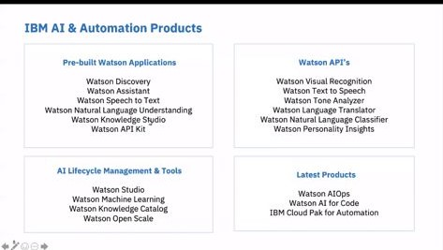

**(S.s During Webinar)**

**Natural Language Processing-NLP:**

Text pre processing is traditionally an important step for natural language processing (NLP)tasks. It transforms text into a more digestible form so that machine learning algorithms can perform better.



**Confusion Matrix:**

It is used for model performance validation. By looking at a confusion matric, we can gain a better understanding of the strengths and weakness of our model, and we can better compare two alternative models to understand which one is better for our applications.

|  |  |
| --- | --- |
| Actually  Positive(1) | Actually  Negative(0) |
| Predicted  Positive(1) | True  Positives  (TPs) | False  Positives  (FPs) |
| Predicted  Negative(0) | False  Negatives  (FNs) | True  Negatives  (TNs) |

True Positives: The number of positive examples that the model correctly classified as positive.

* True Negatives: The number of negative examples that the model correctly classified as negative.
* False Positives: The number of negative examples that the model correctly classified as positive.
* False Negatives: The number of positive examples that the model correctly classified as negative.

**Noise And Bias in Data:**

* Noise is a distortion in data, that is unwanted by the perceiver of data.
* Bias is the simple assumptions that our model makes about our data to be able to predict new data.



**Conclusion**

* Artificial Intelligence makes help us do everyday things such as connecting with friends, using an email or using a ride-share service.
* If you have reservations about the use of artificial intelligence, it may be comforting to know that most of us have been using AI on a daily basis for many years.
* Automation is shaping the future of industries and business to such a level that nothing might be the same in a workplace in the next 10-15 years.
* To benefit from this advancing technology, education need to be adapted to fit the future workforce demandour lives more efficient every day, AI powers may program and services that s.

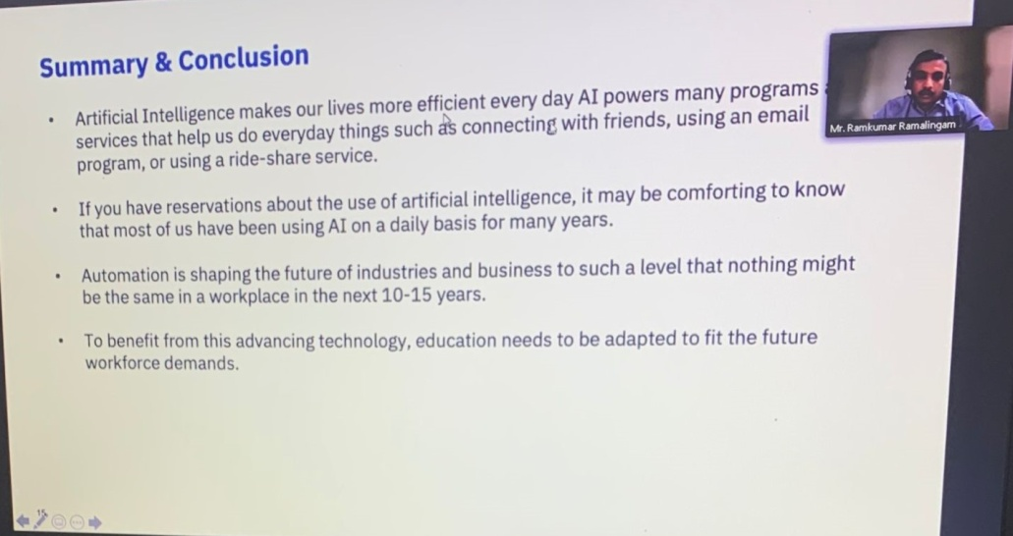

Master Class by :-

Mr. Ramkumar Ramalingam –

Leader IBM Automation Team



Part 2:- **Big Data & Fintech (On:23 Oct 2021)**

**FINTECH:**

The term fintech refers to the synergy between finance and technology, which is used to enhance business operations and the delivery of financial services. Fintech can take the form of [software](https://courses.corporatefinanceinstitute.com/courses/free-excel-crash-course-for-finance), a service, or a business that provides technologically advanced ways to make financial processes more efficient by disrupting traditional methods.

 Some of the most prominent applications of fintech are mobile payments, automated investment apps ([Robo-advisors](https://corporatefinanceinstitute.com/resources/knowledge/trading-investing/robo-advisors/)), cryptocurrency, online lending businesses, and crowdfunding platforms

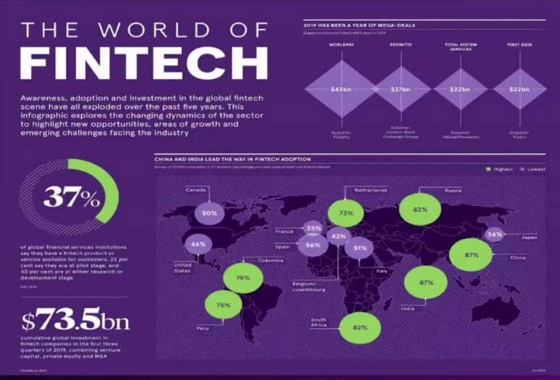



**Technologies that Contribute to Fintech**

**Artificial Intelligence (AI) and Machine Learning (ML)**

Artificial Intelligence (AI) and Machine Learning (ML) are some of the most used technologies in fintech, offering the potential to play an even bigger role in the finance industry as developments continue. Some of the fintech applications of AI and ML include [credit scoring](https://corporatefinanceinstitute.com/resources/knowledge/credit/credit-score-analysis/), fraud detection, regulatory compliance, and wealth management

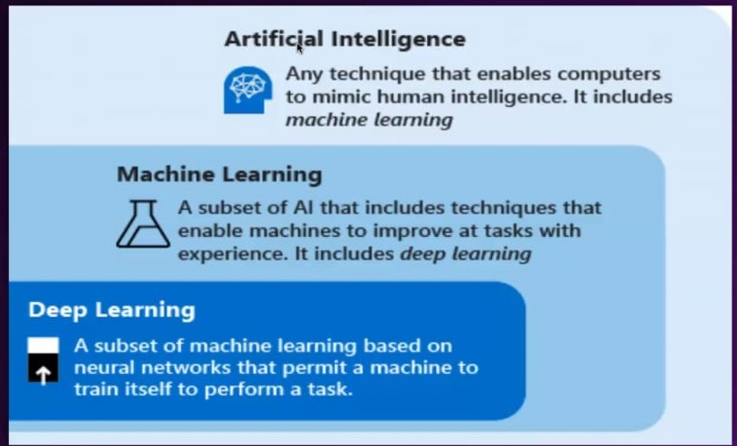



**BIG DATA**

Big data is a collection of massive and complex data sets and data volume that include the huge quantities of data, data management capabilities, social media analytics and real-time data. Big data analytics is the process of examining large amounts of data. There exist large amounts of heterogeneous digital data. Big data is about data volume and large data set's measured in terms of terabytes or petabytes. This phenomenon is called Bigdata. After examining of Bigdata, the data has been launched as Big Data analytics.

Big data is a collection of massive and complex data sets and data volume that include the huge quantities of data, data management capabilities, social media analytics and real-time data. Big data analytics is the process of examining large amounts of data. There exist large amounts of heterogeneous digital data. Big data is about data volume and large data set's measured in terms of terabytes or petabytes. This phenomenon is called Bigdata. After examining of Bigdata, the data has been launched as Big Data analytics. In this paper, presenting the 5Vs characteristics of big data and the technique and technology used to handle big data.

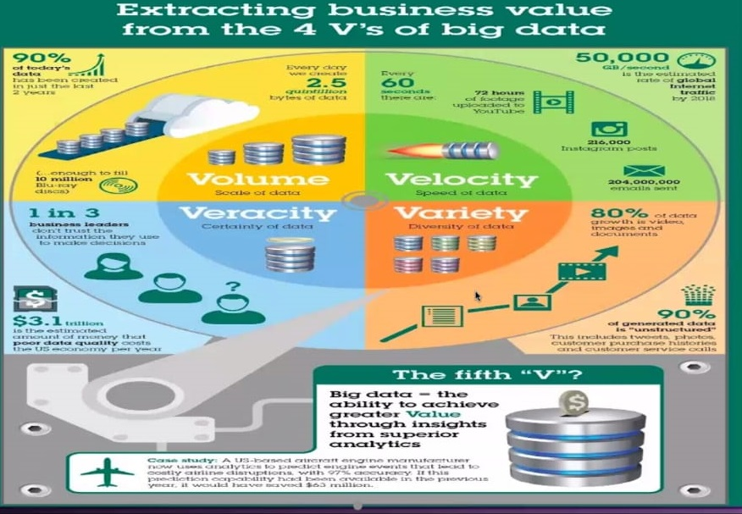



**Blockchain**

Blockchain technology is being adopted at a large scale in the financial industry, primarily due to its ability to securely store transaction records and other sensitive data. Each transaction is encrypted, and the chances of successful cyber-attacks are relatively low when blockchain technology is employed. Blockchain technology is also the backbone of many [cryptocurrencies](https://corporatefinanceinstitute.com/resources/knowledge/other/cryptocurrency/).

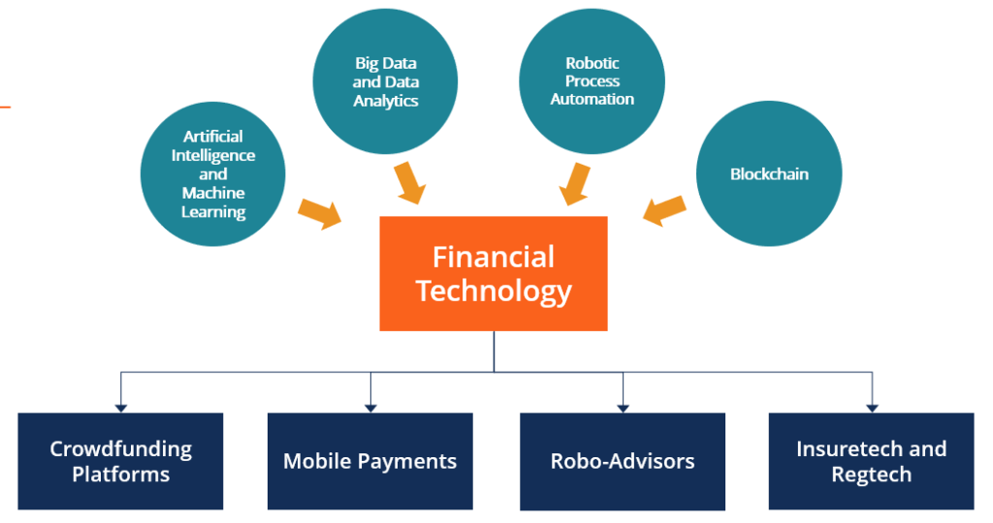

**CONCLUSION:-**

1.To encourage financial services companies to be more efficient

2.To encourage innovation of financial products and services

3.Is a solution to the complexity in the service industry sector

4.Fintech based industry as a unique financial service is currently developing their owned ecosystem which might not to be the same with the current stable financial services.



Part 2:-AI (Autonomous Vehicles) **(On: November 20th, 2021)**

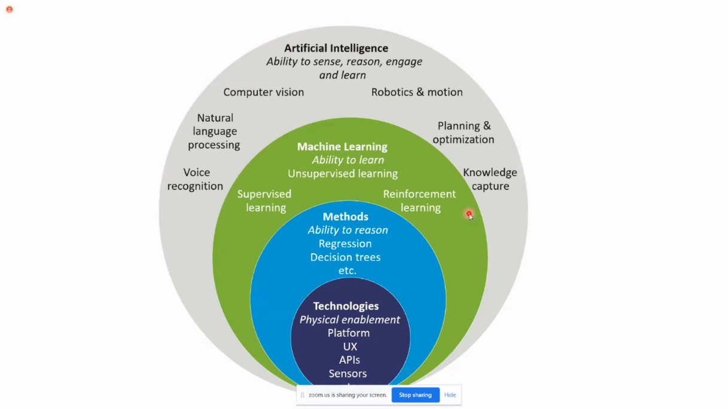

**Venue/Online Platform: Zoom Meeting (Online Platform)**

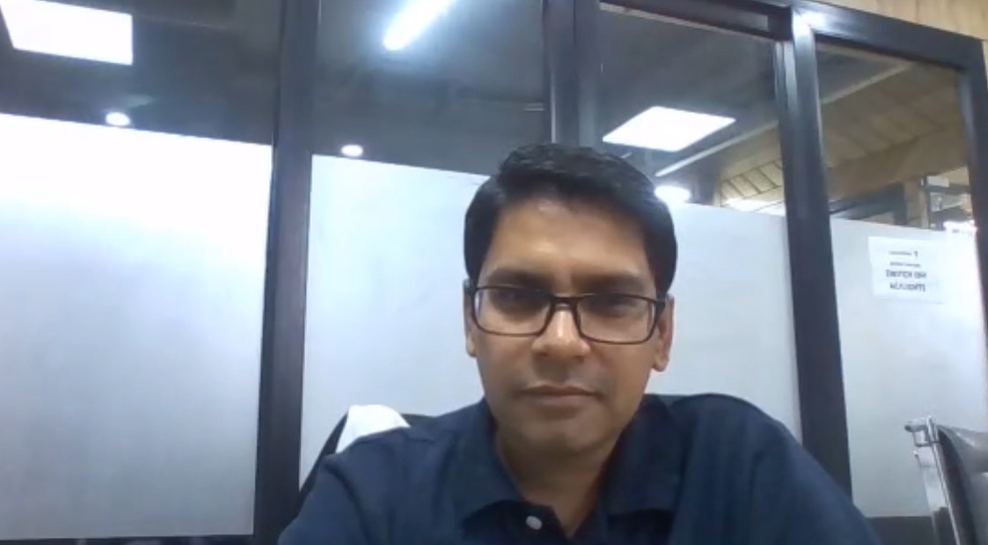

**Industry Expert Details:**

Mr. Lalit Sharma

(Head of Emerging Technology and Innovation Centre at Yamaha Motor Solutions India Pvt. Ltd.)

**Synopsis:**



A webinar was conducted by Chitkara University having Mr. Lalit Sharma as the key speaker who have a high intellect on driving Digital Transformation (DT) in Yamaha Motor India (manufacturing sector), technologies around IoT, Mobility, Connected Vehicle, HoloLens, Industry 4.0 with an ecosystem of Technology Partners and Startups. The webinar was under the course Emerging Technologies and was astonishingly managed and surveilled by Mrs. Jasmeet Kaur who is Manager (Career Advancement Services) at Chitkara University.

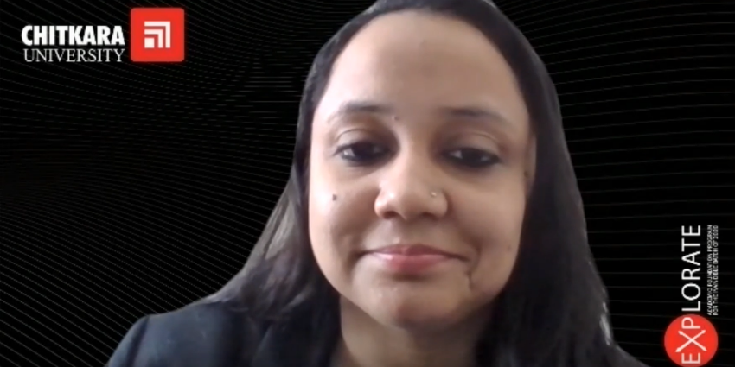

Mr. Lalit started the webinar discussing the basics of AI and machine learning but as it is already discussed and detailed in the previous emerging technologies so he directly jumped to the very basic necessities that makes any businesses organization successful and that is as we know traffic, audience and that is gathered by getting the character patterns with the help of AI and machine learning. Sweet oldest about how and today's Era every organization (successful ones) desperately needs machine learning to be a huge part of it. Then he showed us the model timelines how the business model has evolved from the 90’s to the present day.

**Then he explained about artificial intelligence and machine learning life cycle as follows:**

Then he told us about the various autonomous vehicles Yamaha motor solution is currently working on and how yah machine learning is implemented to almost all of them and how it help in changing different scenarios in a positive manner and how customer friendly at is and how it is getting better and better with customer's feedback you also told us about some of the vehicles for the projects that are made or are being in process by the company. Video for more in depth explanation:

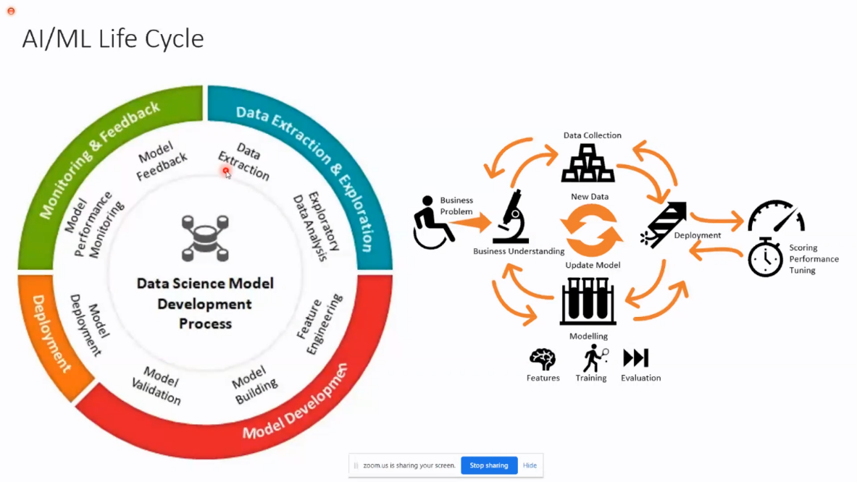

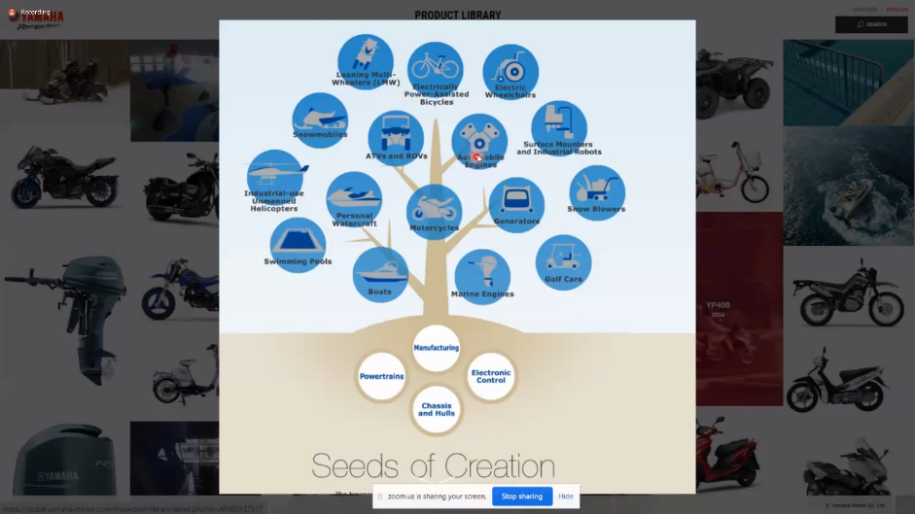

Sir also told us about the customer enrollment program at Yamaha motor solutions and how it is completely based on machine learning and AI. How new customer is enrolled and how alongside with basic personal details the photograph is also taken and that photograph is recognized by the artificial intelligence program for future references and how the app automatically collect customer data and his interests and like on which product he spent more time and in which he might be interested in and what might be his budget and how interested the person is in my product also how frequently the customer visiting the nearest outlet and how much time is pending in the outlet. All of this just by and that do with the help of your facial recognition. Enter the outlet that provides all your details, past history, past visits etc. to the executive of the outlet just by seeing your face.



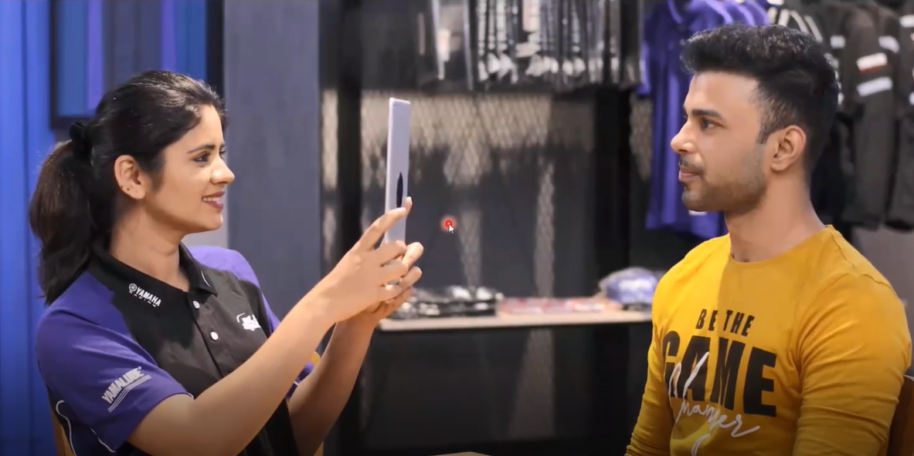

**Concluding** the webinar, Sir told the students to ask queries enabling them to express their questions or doubts or any suggestions about all the topics on his email id so that he can answer them in detail. Overall, it was a fabulous webinar conducted by Chitkara University and one graft a lot of knowledge and information about the respective topics.

**Seminar on:-**

**Creative Innovative India**

**Introduction**

Creativity is an enormously important resource for speeding up economic growth and human development, especially in Third World settings in which social transformation from traditionalism to modernity is urgent. This paper takes the view that Human Resource Management models need to be extended to embrace whole societies, not confined just to business organizations. It seeks to identify the factors that advance creativity and innovation in Third World societies, especially India. Based on the views of a number of scholars representing diverse disciplines, it develops a model of the factors that propel a society towards more creativity and innovation. It makes a preliminary face validity test of the model on a few societies known to be relatively highly innovative. On applying the model to India, it locates three key areas for accelerating creativity and innovation in India: government, educational institutions and civil society. The paper presents a number of suggestions on how creativity and innovation in Third World contexts can be spurred through innovation-enhancing design and functioning of government administration, educational bodies and civil society institutions.

Although Indians are not stereotyped as leaders, they might be stereotyped to have advanced technology skills (Raghuram, 2011). Particular practices and policies in a country influence behaviors or skills in the society and which behaviors or skills are valued in that society (Khandwalla, 2014). Such mechanisms can also influence stereotypes about people who are associated with that society.

For example, in the early 1990s a large number of companies started to outsource IT services to India, which reinforced Indian’s capability in IT (Agrawal, Goswami, & Chatterjee, 2010). Also, the Indian government facilitates skills for product development by emphasizing a high priority on state-of-the-art education in technology (Cappelli, Singh, Singh, & Useem, 2015; Khandwalla, 2014). Such practices and policies might also be a reason why Indians are believed to have a particular ability or "brilliance" for new product development; and technical and IT related skills (Agarwal & Brem, 2012; Hossain, 2017). ...

... This might create a stereotype of the 'Indian technology expert'. This stereotype is likely to make others belief that Indians perfectly fit job roles related to technology (Khandwalla, 2014; Sy et al., 2010). ...

**Details**

* The Scheme aims at raising IPR awareness amongst students, youth, authors, artists, budding inventors and professionals to inspire them to create, innovate and protect their creations and inventions across India including Tier 1, Tier 2, Tier 3 cities as well as rural areas in the next 3 years.
* The Scheme for IPR Awareness aims to conduct over 4000 IPR awareness workshops/seminars in academic institutions (schools and colleges) and the industry,including MSMEs and Start-ups, as also IP training and sensitization programmes for enforcement agencies and the judiciary.
* Workshops will cover all vital IP topics including international filing procedures, promotion of Geographical Indications and highlighting the ill effects of piracy and counterfeiting.
* The Scheme for IPR Awareness would be implemented through partner organizations to promote innovation and entrepreneurship.

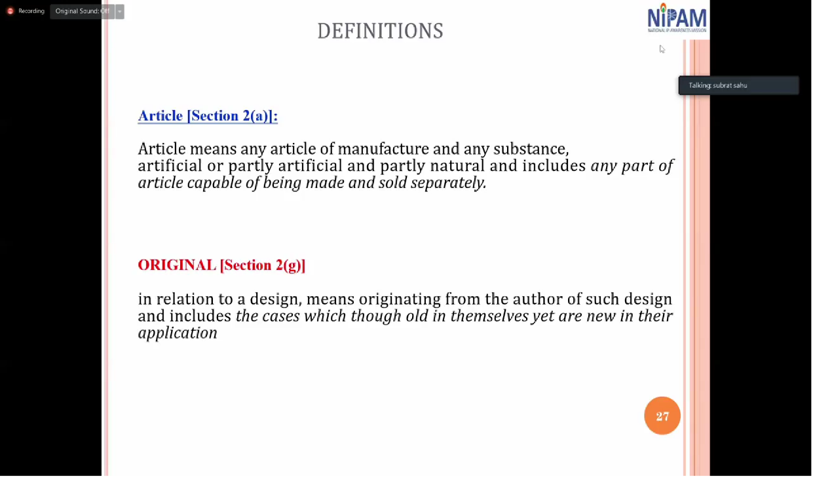

**Highlights of National Intellectual Property Rights (IPR) Policy, 2016**

* The new policy calls for providing financial support to the less empowered groups of IP owners or creators such as farmers, weavers and artisans through financial institutions like rural banks or co-operative banks offering IP-friendly loans.
* The work done by various ministries and departments will be monitored by the Department of Industrial Policy & Promotion (DIPP), which will be the nodal department to coordinate, guide and oversee implementation and future development of IPRs in India.
* The policy, with a tagline of Creative India: Innovative India, also calls for updating various intellectual property laws, including the Indian Cinematography Act, to remove anomalies and inconsistencies in consultation with stakeholders.
* For supporting financial aspects of IPR commercialisation, it asks for financial support to develop IP assets through links with financial institutions, including banks, VC funds, angel funds and crowd-funding mechanisms.
* To achieve the objective of strengthening enforcement and adjudicatory mechanisms to combat IPR infringements, it called for taking actions against attempts to treat generic drugs as spurious or counterfeit and undertake stringent measures to curb manufacture and sale of misbranded, adulterated and spurious drugs.
* The policy will be reviewed after every five years to keep pace with further developments in the sector.
* IPR friendly loans to less empowered groups like artisans, weavers etc.
* Motivating industries to use CSR funds to support IP development.

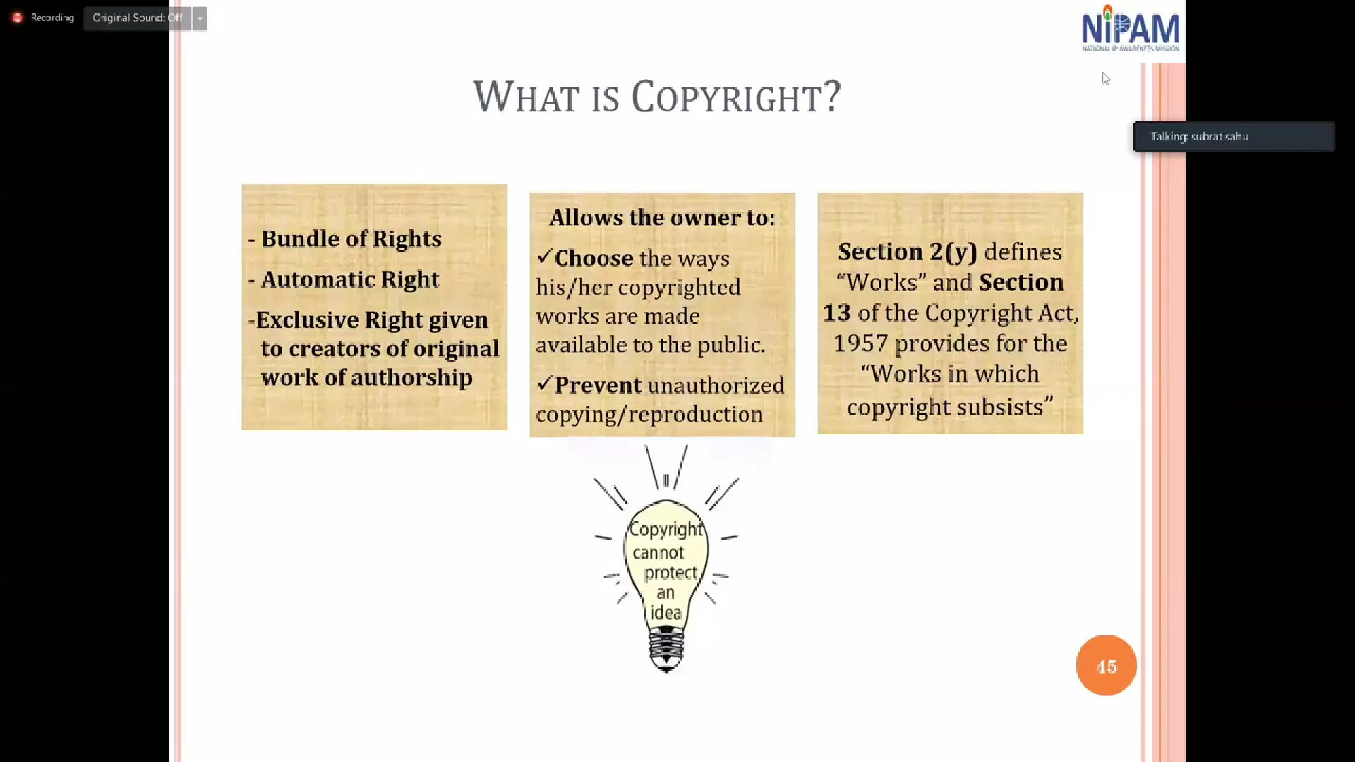

**Conclusion**

A country’s future rests on the shoulders of its youth and children, quite specifically on how they are taught and engaged to think and act. If the 21st Century is truly the age of cataclysmic change and creativity then nothing less than a paradigm shift in the education system will do. While technology increasingly will play a major role in disrupting legacy education models it will equally place heightened emphasis on human beings’ capacity to create and innovate in the face of rapid change and complexity. This will require the resurgence and burnishing of human creativity and the skills that express it, namely questioning and curiosity, awareness, observation, discovery and experimentation, association, application and networking. By igniting these skills through active learning – a process that is both affordable and replicable at scale – the education system can help to catalyse rather than stifle positive change.